Exercise 2 (Based on http://csi.uticak12.org/csi_partners01.htm )

- Toggle site window to local view (see printed sheet of remote/local view – it is icon #4).
- Scroll local view list and select file: “ Exercise2_base.htm” – double click on icon to left of file name.
- The html page will open. (see printed sheet of file with local view and properties window below page).
- In MS Word, open file: “ /handouts/TextForExcercise2.doc”
  - Select and copy 1st paragraph
  - Back in Dreamweaver, select the text “XXX” and paste 1st paragraph.
  - Select text, and in the properties window to the right of “Class” select “copyMain” from pull-down menu – you will see the text formatted using this style.
- Now we will insert a table with 2 columns, 1 row for the bulleted lists of the 3 lists of partners:
  - Place cursor below 1st paragraph, then in the top menu select: Insert/Table. (See below)
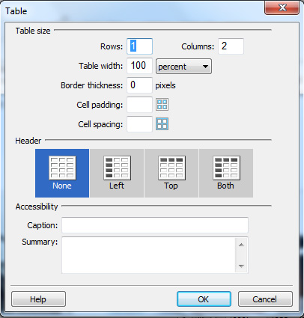
Rows: 1
Columns: 2
Table width: 100%
Border: 0
  - Click “Ok” button to insert table.
  - From the top menu, file/save.
- Now we will jump ahead a couple of steps. In Dreamweaver open file:
”Exercise2_step2.htm
- You will see I’ve added the 3 lists. We will now format each list to have the following:
  - List titles – will use class “PartnerTitles” text formatting:
Select each title one by one, go to class pull-down menu in the properties window to assign each title the correct text formatting
  - Create bulleted lists for each of the 3 lists:
Select the list minus the list title. In the properties window select the unordered list icon to assign a bullet point. It will appear before the 1st word of the list.
  - Put your cursor to the left of the next line of text. Use the backspace to bring it up a line, then use the “enter” key to assign a bullet point to this line.
  - Continue until all bullet points have been assigned
  - Select entire list minus title and assign “copyMain” using the properties window class pull-down menu.
  - Repeat this for the other two lists.
- Adding links and targets to items in the 3 lists.
  - Select “Automation Alley”.
  - In the “TextForExercise2.doc” file, select the link for Automation Alley and copy the link.
  - Back in Dreamweaver, in the properties window just below the “Class” section is “Link” and a white field. Put your cursor in the white link field and use keyboard shortcut “Ctrl-V” to paste the link.
  - To the right of the link field is where you assign the target window to load the link. Since we are linking to other sites, the protocol is to load the link in a separate browser window, so that you don’t send the view away from your site. Select from the Target pull-down menu “_blank”.
  - Continue this process to assign each link to the text. Note that in list one, the “MSU Confucius Institute and Municipal Education Commission of Chonqing, China” has 2 links. I’ve underlined the text to indicate where the links go.
  - Save your document.
- Toggle the local files view to the remote site/local site view.
- Select the file “Exercise2_step2.htm in the local view
- Click on the blue “put” arrow” to upload the page to the remote server.
- To view your handy work, click on this link:
http://csi.uticak12.org/training2012/Exercise2_step2.htm
Note that we include the folder “training2012/” in the file path, a we are working inside of that folder.

